Name: Tushar Muley

Assignment: Exercise 4.2 Scatter plot, Bubble chart, Density Chart

Date: October 24, 2021

**Python Scatter Plot:**

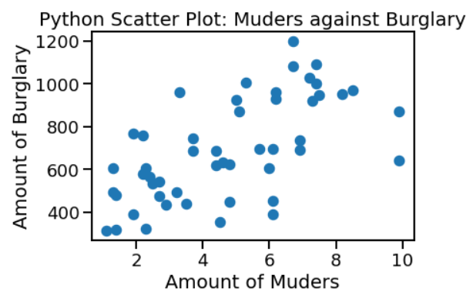

**Python Bubble Chart:**

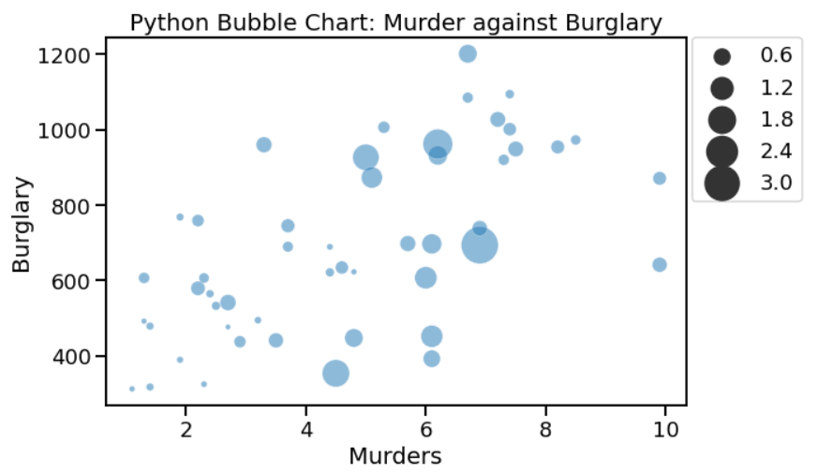

**Python Density Chart:**

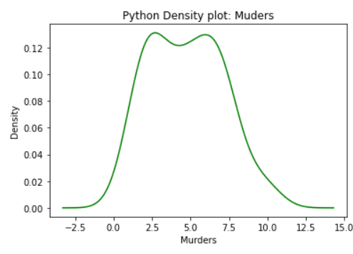

**Tableau Scatter Plot:**

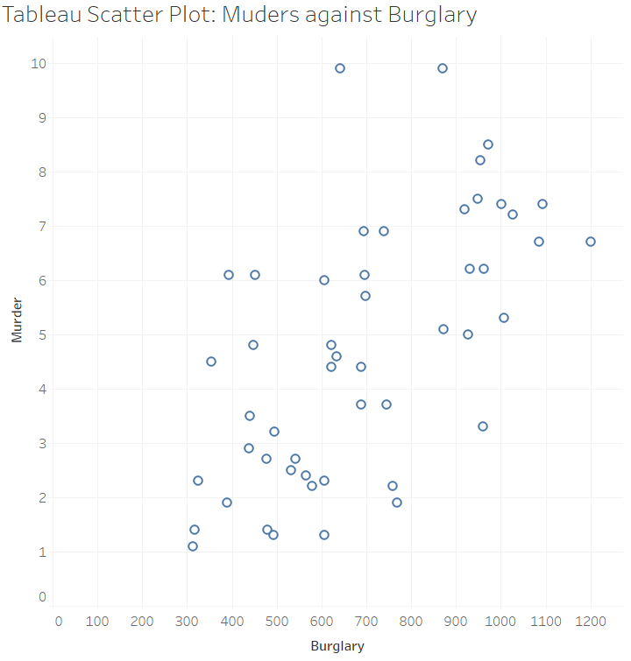

**Tableau: Bubble Chart:**

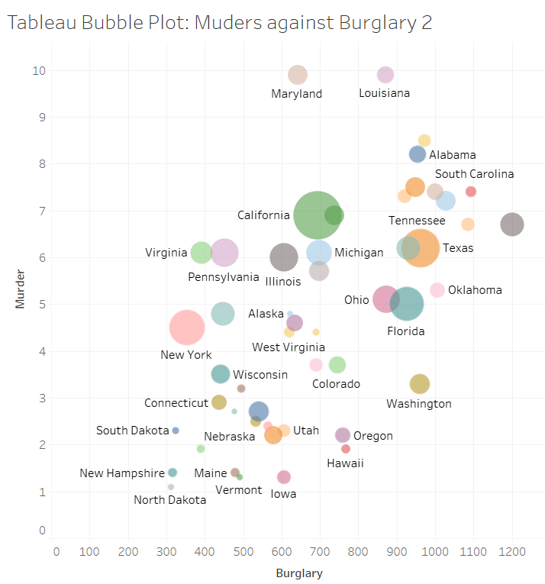

**Tableau Density Map:**

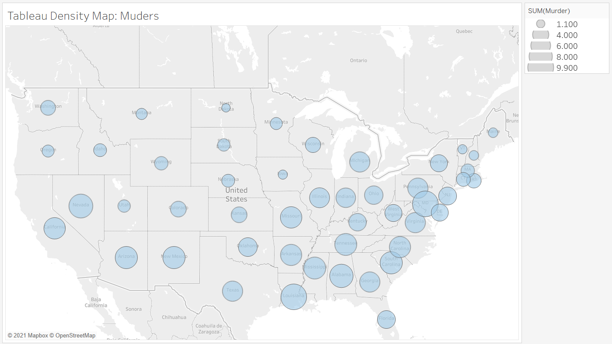

**R Scatter Plot:**

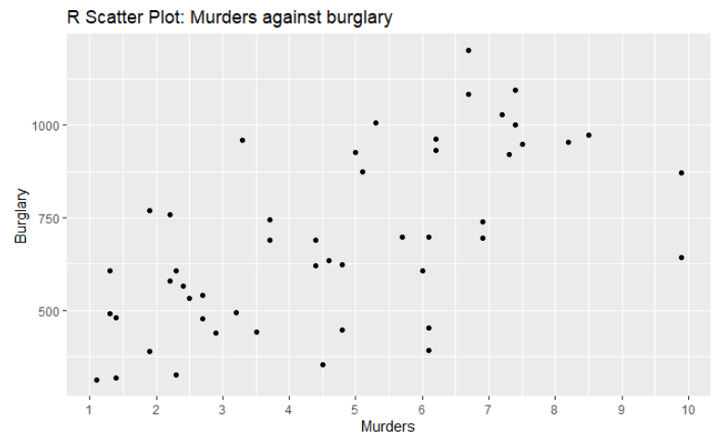

**R Bubble Chart:**

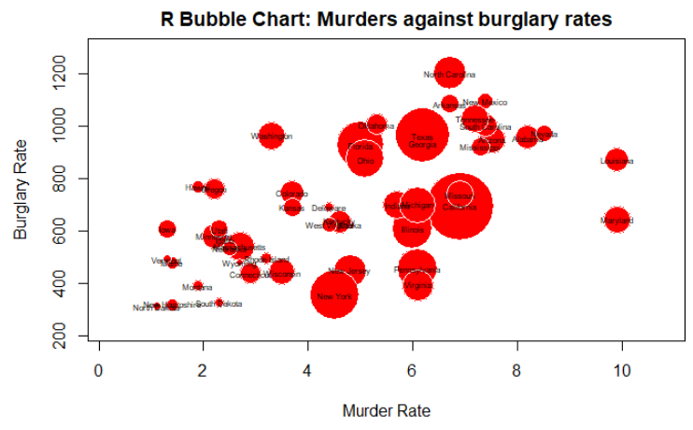

**R Density Plot:**

